Understanding Bradford District | City of Bradford Metropolitan District Council  Intelligence Bulletin | October 2016

Social Care & Support for Children

At a glance:
- Referrals to social care services for children are below national rates.
- The total number of ‘Children in Need’ in Bradford during 2015/16 was 8,537.
- The number of children being looked after as at 31 March 2016 was 848.

Children in need of care and protection
The numbers of referrals to Children’s Social Care peaked in Bradford in mid-2009 with just under 600 referrals per 10,000 children following the high profile deaths of children elsewhere in the UK. There has since been a reduction in demand for higher-level social work interventions below the national rate, with referrals over the past few years remaining at about 350 per 10,000 children. In 2015/16 there was an increase to 5,549 referrals (396 per 10,000 children); however this is still considerably below the most recently published England average of 548 referrals per 10,000 children
(31 March 2015).
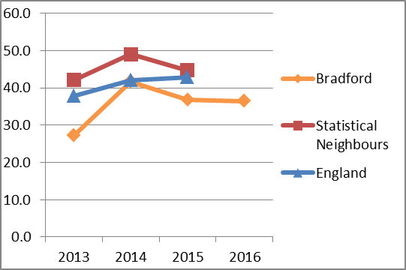
Figure 1 - Child Protection Plans per 10,000 children under 18

Bradford has lower than average numbers of children recorded by social care as ‘Children in Need’. The total number of ‘Children in Need’ in Bradford during 2015/16 was 8,537. Of the 3,848 children’s cases open at 31 March 2016, about 40% were of Black and Minority Ethnic (BME) origin, where ethnic origin was recorded.

A smaller proportion of children in Bradford become the subject of a Child Protection Plan compared to national rates. The rate had risen sharply in 2014 to 41.7 per 10,000 children, but fell in 2015 to 36.9 per 10,000 children. The number has fallen slightly further by 31st March 2016 to 36.5 per 10,000 children, well below the most recently published averages of 42.9 per 10,000 children across England and 44.7 per 10,000 across our Statistical Neighbours (31 March 2015).

The number of children being looked after as at 31 March 2016 was 848, a rate of 60.6 children per 10,000 children; in line with the national rate of 60 per 10,000 but below the Statistical Neighbours average of 78 per 10,000. The number of Looked After Children in Bradford fell slightly during the year 2015-16 compared to 2014-2015 of 878.

Under the 1989 Children Act, a child in need is one assessed as requiring a service from the local authority if they are not to experience poor outcomes.
The Department for Education divides Local Authorities into Statistical Neighbour groups with similar local demographics. Bradford has ten Statistical Neighbours including Kirklees, Rochdale, Walsall and Derby.

