Understanding Bradford District | City of Bradford Metropolitan District Council  Intelligence Bulletin | October 2016

Economy

At a glance:
- Bradford is a big economy worth £9.2bn and is the eleventh largest economy in the UK.
- Growth in the district’s GVA between 2013 and 2014 was 2.7% which was lower than the Yorkshire and Humber growth of 3.3% and UK growth of 4.6%.
- Bradford has 17,620 businesses employing 193,200 employees.
- Following recession Bradford has seen business numbers exceed pre-recession levels.
- Bradford has one of the highest business start up rates in the UK though it is now slowing which may reflect a strengthening jobs market.
- Bradford retains a strong manufacturing base with 25,000 jobs, the 3rd highest in the UK.
- High value added and knowledge intensive industries are under-represented in Bradford.
- Despite improving skills levels, Bradford residents’ earnings lag regional and national averages.
- Bradford residents occupational profile is skewed towards lower skill occupations

Economic Output and Productivity
Bradford is a big economy worth £9.2bn and is the eleventh largest economy in the UK and eighth in England. It is the third largest in the Yorkshire region after Leeds and Sheffield.
Growth in the district’s Gross Value Added between 2013 and 2014 was 2.7% which was lower than the Yorkshire and Humber regional and UK national rates of growth for 2013 and 2014 at 3.3% and 4.6% respectively.
Bradford District Total GVA Trends 1997 - 2014

Source: Office for National Statistics (ONS)

GVA is also measured per head of population. Bradford has a relatively low GVA per head of population figure. At 2014 Bradford’s per head figure at £17,366 was far lower than the West Yorkshire (£20,808) and national (£24,958) averages and also lower than the Yorkshire and Humber (£19,863) regional average.
Headline GVA at current basis prices 2014*
 | GVA Per Head |  | Total GVA
NUTS 3 areas | 2014 (£) | % change  2013-2014 | 2014  (£million) | % Change  2013-2014 | % of Yorkshire & Humber total
Bradford | 17,366 | 2.40% | 9,172 | 2.70% | 8.60%
Leeds | 26,341 | 2.30% | 20,188 | 2.90% | 19.00%
Calderdale & Kirklees | 17,755 | 3.00% | 11,335 | 3.60% | 10.60%
Wakefield | 19,382 | 1.00% | 6,423 | 1.50% | 6.00%
West Yorkshire | 20,808 | 2.30% | 47,117 | 2.80%
Yorkshire & Humber | 19,863 | 2.80% | 106,467 | 3.30%
United Kingdom | 24,958 | 3.40% | 1,618,346 | 4.60%
Source: Regional Accounts , Office for National Statistics ( * 2014 data is provisional )

Businesses in Bradford
The onset of the recession in 2008 resulted in significant falls in business numbers and employee jobs across Bradford District. Following the recession Bradford has experienced a big improvement that has seen business numbers exceed pre recession levels.
Between 2011 and 2015, the number of businesses in the District increased by 2,470 to 17,620. This was an increase of 16.3% which was slightly lower than the City Region growth of 17.4 % and below UK growth of 18.1%. Bradford accounts for 14.3% of all businesses in the Leeds City Region which is lower than our share of work age people at 17.3%.
Business Numbers | Bradford | Leeds City Region | UK
Total businesses 2015 | 17,620 | 121,635 | 3,010,060
Growth in businesses 2011-15 | 2,470 | 18,080 | 462,220
% Growth in businesses 2011-15 | 16.3% | 17.4% | 18.1%

Bradford recently ranked 11th in a list of the top locations for start-up businesses in the UK by the Centre for Entrepreneurs (CFE). The study found that 2015 was a record year for British start-ups. London topped the list, followed by Manchester, Birmingham and Leeds. Sheffield came in 13th.

Businesses by Size
The majority of businesses in Bradford are micro business with 82% of all businesses employing less than 10 people. There are only 665 businesses employing 50 or more people which is 3.9% of all businesses compared to 3.7% across Leeds City Region as whole and 3.1% nationally. Bradford is slightly more dependant on larger employers.
Business by Sector | Bradford |  | Leeds City Region | UK
 | Number | % of total | % of total | % of total
Total businesses in 2015 | 17,620 | 100.0 | 100.0 | 100.0
Micro (0-9) | 14 555 | 82.0 | 81.9 | 83.6
Small (10-49 | 2,400 | 14.1 | 14.4 | 13.3
Medium (50-249) | 575 | 3.4 | 3.2 | 2.7
Large (250+) | 90 | 0.5 | 0.5 | 0.4

Business numbers by Sector
The majority of businesses in Bradford are in the service sector with 14,520 businesses which 81.8% of all businesses. This is slightly higher than regional and national figures. Bradford also has a higher proportion of manufacturing businesses, particular in comparison to the national picture.
Business by Sector | Bradford |  | Leeds City Region | UK
 | Number | % of total | % of total | % of total
Total businesses 2015 | 17,620 | 100.0 | 100.0 | 100.0
Primary | 420 | 2.5 | 4.4 | 5.8
Manufacturing | 1,225 | 7.2 | 6.2 | 4.8
Construction | 1,455 | 8.5 | 9.7 | 10.1
Services | 14,520 | 81.8 | 79.7 | 79.3
Change 2011-15 | Number | % Change | % Change | % Change
All businesses | 2,135 | 14.3 | 14.9 | 14.1
Primary | 45 | 12.0 | 10.2 | 7.5
Manufacturing | 25 | 2.1 | 3.5 | 5.3
Construction | 65 | 4.7 | 4.2 | 8.0
Services | 1,990 | 16.7 | 17.7 | 16.1

Bradford’s total number of businesses in 2015 is now higher the 2009 pre-recession total. The majority of new businesses were service sector businesses with an increase of 1,990 that was 93% of the total increase. Growth of service sector businesses was higher the UK average but lower than the overall Leeds City Region increase.
Bradford had a bigger than average increase in the number of primary sector businesses and a lower than average increase in manufacturing businesses.
Construction businesses growth was much lower than the UK figure but higher than the city region average.

Business Trends By Sector

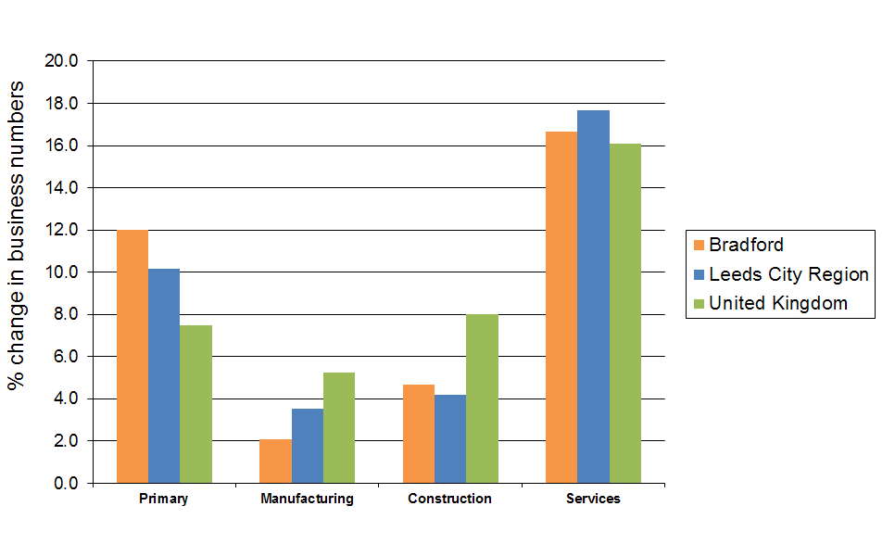

Business start ups, closures and survival
Business start ups are important to improving the District’s relatively low business density level. The recession reduced the number of business births by 290 between 2007 and 2011. Latest data shows a big upturn in business births and a decrease in business deaths although the birth growth rate at 1.3% was below West Yorkshire and England averages of +2.5% and +12% respectively. Business closures reached a high of 1,785 in 2009 but fell for two consecutive years to 1,425 in 2011.

 | Bradford | West Yorkshire | England
Total businesses 2015 | 17,620 | 121,635 | 3,010,060
Business Births 2014 | 2,150 | 10,515 | 350,585
Business Deaths 2014 | 1,550 | 7,360 | 245,835
Change (number) | +600 | +3,155 | +104,750
Rates per 10,000 work age population (16-64) 2014
Business birth rate | 65 | 73 | 85
Business death rate | 47 | 51 | 60
Business stock (density) | 478 | 524 | 622
Survival rate - one year from 2013 | 94.9% | 94.2% | 93.5%
Survival rate - five years from 2009 | 42.3% | 42.0% | 41.7%

Over recent years Bradford’s one year business survival rate improved relative to other areas. 94.9% of businesses formed in Bradford in 2013 survived for a year compared with 93.5% in England and 94.2% in West Yorkshire. Bradford’s five year survival rate at 42.3% was higher than the England (41.7%), and West Yorkshire (42.0%) rates.
Business Births and Deaths in Bradford 2007 - 2014
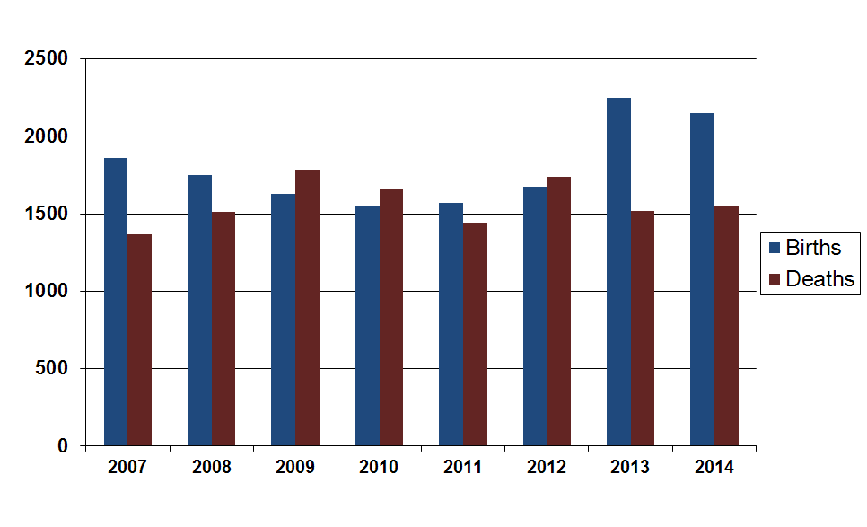

Employee Jobs
The number of employee jobs in Bradford was 193,200 in September 2015, an increase of 4,000 employee jobs over the year equating to a 2.1% increase. All of the ten districts in Leeds City Region (LCR) experienced growth in employee job numbers giving rise to an overall increase of 2.5%. Overall employee jobs grew by 2.1% in Great Britain.
Number of employee jobs 2014 and 2015
 |  |  | Change 2014 to 2015
Area | 2014 | 2015 | Number | %
Bradford | 189,200 | 193,200 | 4,000 | 2.1%
Leeds City Region | 1,303,600 | 1,337,400 | 33,800 | 2.5%
Yorkshire & Humber | 2,260,500 | 2,310,179 | 49,679 | 2.2%
Great Britain | 27,950,900 | 28,526,436 | 575,536 | 2.1%
Source: Business Register & Employment Survey 2014/5
The growth in employee jobs in the district was due to increases in manufacturing (+600), construction (+1,000), transport and storage (+1,200) ,finance and insurance (+1,300), business admin (+2,700 ) education (+1,000) , over the same period employee jobs which had decreases were retail( -700) , information and comms ( -800) and public admin (-500)
Private sector job growth was relatively strong, growing by 2.9% or 4,181 jobs over the year to September 2015.. However, public sector employment fell in Bradford over the same period, down by 282 (-0.6%).
Bradford had the lowest employee jobs growth of any local authority district in the Leeds City Region .
Percentage change in employee jobs 2014 to 2015 – LCR districts
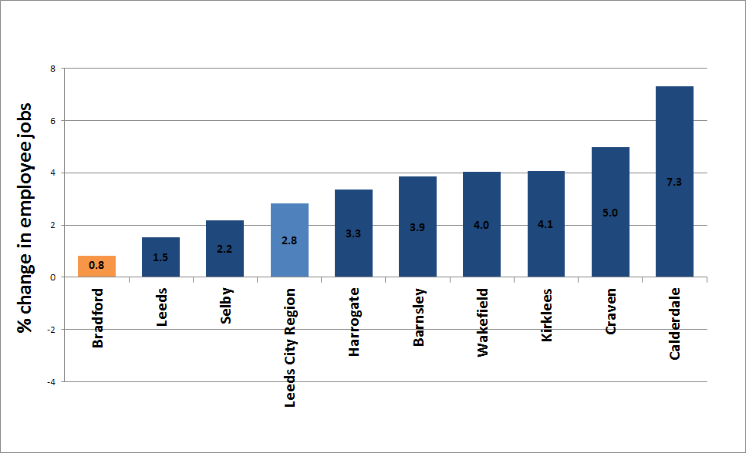
Source: Business Register and Employment Survey, NOMIS

Employee Jobs by Sector
Looking at employment by sector, health is the biggest employer in Bradford District with a total of 31,000 employees or 16.0 % of all employees. Other major employment sectors are manufacturing (24,900 or 12.8%), education (24,000 or 12.3%) and retail (18,000 or 9.3%).
Employee jobs by industry group 2014 – 2015- Bradford
 | 2014 |  | 2015 |  | Change 2014 - 2015
Industry sector | Number | % | Number | % | Number | %
Mining, Quarrying | 3,000 | 1.6 | 3000 | 1.6 | 0 | 0
Manufacturing | 24,200 | 12.8 | 24,900 | 12.8 | 700 | 3
Construction | 6,000 | 3.2 | 7,000 | 3.6 | 1,000 | 16
Motor trades | 4,200 | 2 | 3,500 | 1.8 | -700 | -17
Wholesale | 9,100 | 4.8 | 9,000 | 4.7 | -100 | -1
Retail | 18,600 | 9.9 | 18,000 | 9.3 | -600 | -3
Transport and storage | 6,800 | 3.6 | 7,800 | 4.1 | 1,000 | 15
Accommodation | 9,100 | 4.8 | 9,000 | 4.7 | -100 | -1
Information & Comm | 5,800 | 3.1 | 5,000 | 2.6 | -800 | -14
Financial & Ins | 7,700 | 4 | 9,000 | 4.7 | 1,300 | 17
Property | 3,200 | 1.7 | 3,000 | 1.6 | -200 | -6
Professional scientific | 10,900 | 5.8 | 11,000 | 5.7 | 100 | 1
Business admin & supp | 10,300 | 5.4 | 13,000 | 6.7 | 2,700 | 26
Public admin & def | 9,500 | 5 | 9,000 | 4.7 | -500 | -5
Education | 23,000 | 12.1 | 24,000 | 12.3 | 1,000 | 4
Health | 31,400 | 16.6 | 31,000 | 16.0 | -400 | 1
Arts recreation | 6,600 | 3.5 | 6,000 | 3.1 | -600 | -9
All industries | 189,200 | 100 | 193,200 | 100 | 4,000 | 2
Source: Business Register and Employment Survey, Nomis

Manufacturing trends
Manufacturing industries experienced a growth of 700 employee jobs over the year to 2015..The largest increase in jobs was in the electronics industry with 560 more jobs , the food and drink industry saw an increase of 270 jobs , the textile industry also had an increase of 270 jobs . The sectors with a fall in jobs included printing and publishing (-356) jobs, the manufacture of plastic products (-300) and the manufacture of wood and furniture (-130) jobs.
Despite the loss of 700 manufacturing jobs between 2009 and 2015, Bradford still has the third largest number of manufacturing employees of any local authority district in Great Britain.

Earnings
Low skills are reflected in lower than average earnings. Median weekly full-time earnings for Bradford residents are £451.60, below the regional average of £480.50 and the UK average of £529.60
But the gap is narrowing - Since 2010 median earnings have increased by 5.8% which is more than a regional increase of 3.9% and national growth of 3.6%.
Gross Weekly Pay

Source: ONS annual survey of hours and earnings - resident analysis

Wage levels reflect the occupation profile of Bradford’s residents. Bradford has more people than average employed in the lower paid elementary occupations and fewer managers and directors than average. Elementary occupations account for 13.3% of Bradford’s employed residents.
At the other end of the occupation profile there are 18,000 or 8.1% of Bradford’s employed residents who are employed as managers, directors or senior officials. This number has fallen by 3000 or 14% since 2005.

Key challenges
- Recent employee jobs growth has been weak compared to regional and national comparators. Private employment growth needs to improve to match city region rates and mitigate continuing public sector job losses.
- The low representation of high value knowledge based industries such as professional and business services is a weakness in the local economy and addressing this is key to moving the District towards a higher value, higher wage economy.
- A growing work age population means an increasing need for job creation. We will need to create an additional 27,000 jobs by 2020 to match the Leeds City Region employment rate.
- Despite improving skills levels, Bradford residents’ earnings lag regional and national averages. Bradford Residents are less likely to be employed in senior management and professional roles despite being the second strongest economy in the City Region.

