Understanding Bradford District | City of Bradford Metropolitan District Council  Intelligence Bulletin | November 2016

Adult Social Care

At a glance:
- Small increases in both social care related quality of life, and satisfaction of people who use services with the quality of care and support.
- The overall proportion of people receiving personal budgets continues to rise, and Bradford provided personal budgets to 86.8% (England average 86.9%) of people who use care and support services.
- The proportion of people who use adult social care services who say those services have made them feel safe and secure increased further.
- The proportion of people who are in receipt of local authority funded care who say they have as much social contact as they would like continues to be high.
- The proportion of people who use services who say they have control over their daily life has also continued to increase.

The Adult Social Care Outcomes Framework
The Adult Social Care Outcomes Framework (ASCOF) is used by BMDC Adult and Community Services to set priorities for care and support, measure progress and strengthen transparency and accountability.

The ASCOF provides us with robust information that enables us to monitor the success of local interventions in improving outcomes, and to identify our priorities for making improvements. We have also used the ASCOF to inform outcome-based commissioning models. It is also a useful resource for our Health and Wellbeing board who use the information to inform their strategic planning and leadership role for local commissioning.

The ASCOF also strengthens accountability to local people. By fostering greater transparency on the outcomes delivered by care and support services, it enables local people to hold their council to account for the quality of the services that they provide, commission or arrange.

We are also using the ASCOF to develop and publish our annual local account to communicate directly with local communities on the outcomes that are being achieved, and our priorities for developing local services.

The quality of care and support
The social care related quality of life indicator provides an overall view of the quality of life the users of their care and support services experience. In 2014/15 the overall score for users of social care was 19.4 (out of a maximum possible score of 24). This increased to 19.5 in 2015/16 (England average 19.1).

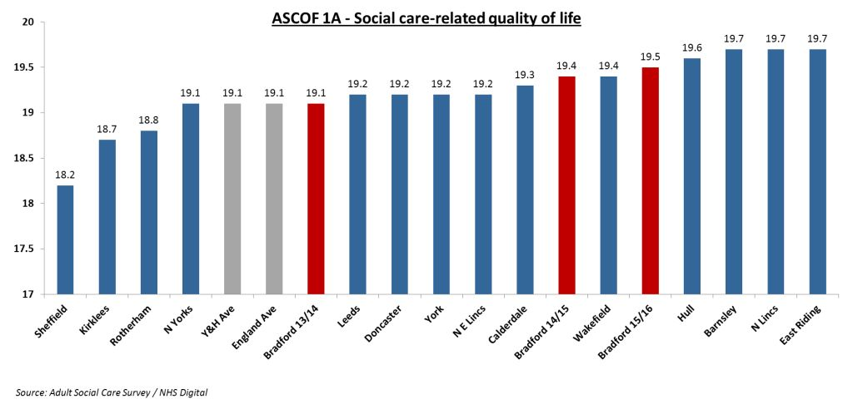

After an increase, from 61.9% in 2013/14 to 62.5% in 2014/15, in the proportion of users who were extremely or very satisfied with the care or support services they received, there has been a further increase to 63.1% in 2015/16 (England average 64.4%).
While it is encouraging that around two thirds of users are extremely or very satisfied with the care and support services they receive, there is room for improvement to ensure that everyone has the best possible experience.

Support to maintain independence as long as possible
For people with learning disabilities or mental health problems, stable accommodation is an important factor in improving their safety and overall quality of life, but can also be a factor in the risk of social exclusion. Bradford has seen an improvement in stable accommodation for people with learning disabilities which has risen from 84.4% in 2014/15 to 86.3% (England average 75.4%) in 2015/16. There has also been an improvement in stable accommodation for people with mental health problems from 66.5% in 2014/15 to 69.1% (England average 58.6%) in 2015/16.
Adults with learning disabilities who live in their own home or with their family

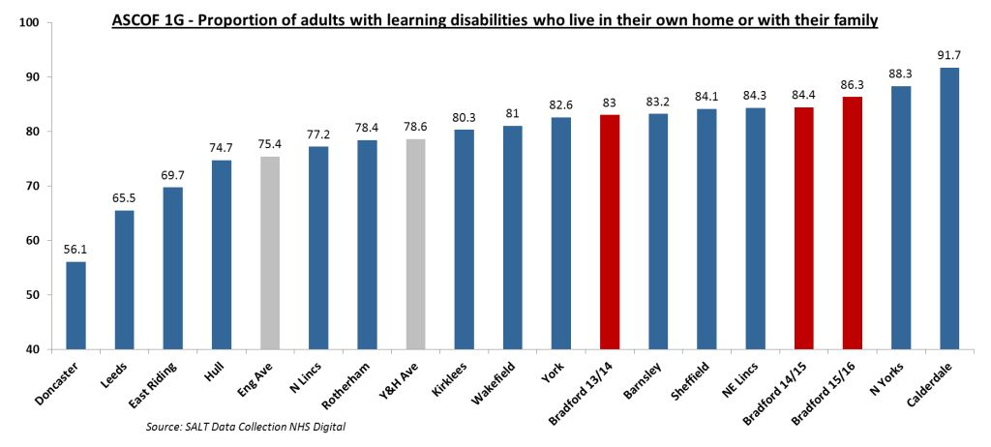
Adults in contact with secondary mental health services who live independently, with or without support

The proportion of people with a learning disability who are in paid employment has increased slightly year on year, from 4.9% in 2014/15 to 5.5% (England average 5.8%) in 2015/16. The proportion of people in contact with secondary mental health services in paid employment has reduced slightly from 7% in 2014/15, to 6.1% (England average 6.7%) in 2015/16. This suggests that there is more that could be done to enable people in these two categories to achieve paid employment.

Reablement services
Reablement or rehabilitation services seek to support people, in order to minimise their need for on-going support and to maximise their independence. ASCOF captures the effectiveness of these services for older people, measuring the proportion of older people still at home 91 days after being discharged from hospital into reablement or rehabilitation services.
The proportion of older people who were still at home 91 days after discharge from hospital into reablement has deteriorated over the last 3 years: 88.2% (England average 82.7%) in 2015/16 compared with 88.8% in 2014/15 and 94.3% in 2013/14. However these figures should be viewed in the context of the total number of older people discharged from hospital, and the proportion of those that were offered reablement services, which has increased from 2.1 in 2014/15 to 2.8 in 2015/16.

Understanding how care and support works
The availability and ease of access to information and advice is vital in helping people, their families and carers to make informed choices about the care they want to receive. The ASCOF measures this by capturing the ease with which people are able to find information about care and support. In Bradford, 70.8% (England average 73.5%) of people in 2015/16 saying that they found it very easy or fairly easy to find information or advice compared with 73.3% in 2014/15 and 71.6% in 2013/14.

Control of care and support
The Government wants to give people more control over their health and social care. Personalisation means building support around the individual and providing people with more choice, control and flexibility in the way they receive care and support – regardless of the setting in which they receive it.
This emphasis on providing care over which users have choice and control is reflected in ASCOF; and the extent to which users of care and support feel in control of their daily lives are the key indicators of the personalisation of care. In 2015/16, 79.2% (England average 76.6%) of users surveyed reported having either as much control as they want or adequate control over their daily life, compared to 77.8% in 2014/15 and 78.1% in 2013/14. While it is encouraging to see over three quarters of people feel in control of their daily lives, it is important that, where possible, more is done to improve outcomes in this area for all who use care and support.
Proportion of people who use services who have control over their daily life

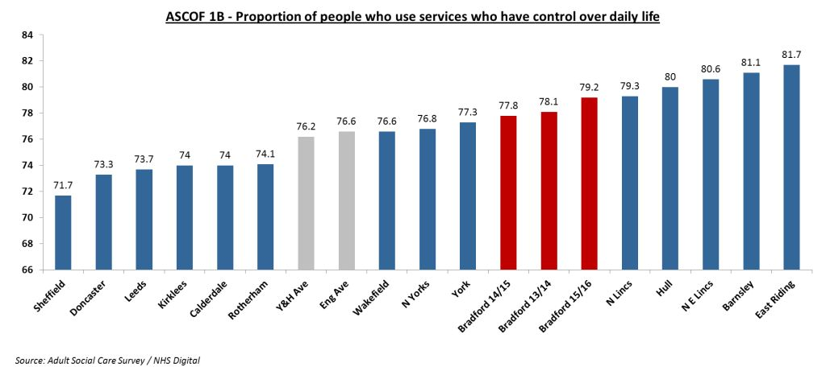
There has been a further increase in the use of personal budgets. The ASCOF showed that 86.8% (England average 86.9%) of users of community based services and received a personal budget in 2015/16, compared to 79.4% in 2014/15, highlighting the continuing progress of Bradford in delivering personalised care.

Safeguarding
The Government’s aim is to prevent and reduce the risk of adults with care and support needs from experiencing abuse or neglect. All adult social care users, including those whose circumstances make them vulnerable, should feel safe and secure. In 2015/16 the proportion of people who said that they felt safe and secure was 73.2% (England average 69.2%), an increase from 2014/15 where the proportion was 70.7%.
The ASCOF also measures how safe the services that users receive have made them feel. In 2015/16 84.4% (England average 85.4%) of adult social care users said that the services they receive have made them feel safe and secure, an increase from 82.3% in 2014/15 and 73.3% in 2013/14.

Social Contact
The social isolation indicator, introduced in 2013/14, has shown that approximately 50% of social care service users do not have as much social contact as they would like. This shows that there is scope for Bradford to make progress in order to achieve social integration for the users of social care services. Overall, compared to Regional and England averages there has been a consistently high proportion of people who said they have as much social contact as they would like, over the last 3 years, from 49% in 2013/14, to 52.2% in 2014/15 and 51.4% in 2015/16 (England average 45.4%).

Permanent Admissions
The number of permanent admissions to residential and nursing care is a good measure of the effectiveness of care and support in delaying dependency on care and support services. The inclusion of this measure in the framework supports local health and social care services to work together to reduce avoidable admissions where appropriate.
For measures regarding delaying dependency for older people in 2015/16 there were 513 (England average 628) permanent admissions to residential care or nursing homes per 100,000 population for adults aged 65 or over. The proportion of younger adults (aged 18-64) who were permanently admitted to care homes was 14 (England average 13.3) per 100,000 population.

Requests for Support: The level of demand for social care services from new clients
Requests for support made in relation to the provision of adult social care services are captured by local authorities, and reported by both the route of access (which setting the request originated from) and their sequel, the outcome of the request (what provision if any was offered). The routes of access are Transition, Discharge from Hospital, Diversion from Hospital Services and through the Community.
The sequels are Short Term Support to Maximise Independence (ST-Max, a range of services that are of short duration typically being provided for a few weeks with the explicit aim of trying to minimise the person’s use of on-going social care services), Long Term Support, End of Life care, On-going low level support, Other Short Term Support, Universal Services, or No services provided.

In Bradford these requests are received by either Adult Services Access Point, via the Social Work teams at the Hospitals or via the Sensory Needs Service at Morley Street.

There were 31,500 requests for support from new clients, which had reached the stage of having a known sequel during the reporting period. 22 per cent of these were from clients aged 18-64, with the remaining 78 per cent from clients aged 65 and over.
46 per cent of requests for support resulted in no direct support from the council and where the individuals were signposted to other services.
29 per cent of requests for support for new clients aged 65 and over came through the Discharge from Hospital route of access (compared to 12 percent of requests from 18-64 year olds).

Short Term Support to Maximise Independence: The impact of a limited period of Short Term Support

This provides some indication of the outcomes of services intended to maximise the independence of new clients. Tracking the sequels to short term services gives an idea of the effectiveness of preventing longer-term reliance on social care.

There were approx. 3,000 completed instances of ST-Max for new clients. Just under half (43 per cent) received ST-Max following a Discharge from Hospital. Of these, 19 per cent had no further needs identified (compared to 17 per cent of all completed ST-Max for new clients).

The majority of clients 2583 (86 per cent) have a Primary Support Reason of Physical Support: Personal Care Support.

There were 480 completed instances of ST-Max for existing clients. 38 per cent of these saw the client returning to Long Term Support.

Long Term Support
Care and Support services are provided or commissioned by BMDC Adult and Community Services with the intention of maintaining quality of life for an individual on an on-going basis.
Long Term support is allocated on the basis of eligibility criteria / policies (i.e. an assessment of need has taken place), and are subject to regular review.
There were 7,630 clients receiving long term support during 2015-16. 5,740 were still accessing long term support at year end, and of these, 5,020 had been accessing long term support for more than 12 months.
85 per cent of clients accessing Long Term Support in a Community setting at year end had a carer identified.
The most common Primary Support Reason for clients aged 18-64 was Learning Disability Support (for 58 per cent of clients), and for clients aged 65 and over it was Physical Support: Personal Care Support (for 73 per cent of clients).

Long Term Support at year end by Primary Support Reason* for Age Band 18 to 64 | Nursing | Residential | Community | TOTAL | %
Learning Disability Support | 48 | 144 | 1,249 | 1,441 | 61%
Mental Health Support | 2 | 12 | 192 | 206 | 9%
Physical Support | 40 | 64 | 431 | 535 | 23%
Sensory Support | 1 | 3 | 34 | 38 | 0.2%
Social Support | 0 | 11 | 0 | 8
Support with Memory and Cognition | 29 | 76 | 28 | 133 | 6%
TOTAL | 120 | 310 | 1,934 | 2,364 | 100%
Long Term Support at year end by Primary Support Reason for Age Band 65+ | Nursing | Residential | Community | TOTAL | %
Learning Disability Support | 18 | 55 | 74 | 147 | %
Mental Health Support | 2 | 4 | 13 | 19 | %
Physical Support | 279 | 788 | 1,588 | 2,655 | %
Sensory Support | 1 | 4 | 24 | 29 | %
Social Support | 0 | 1 | 0 | 1 | %
Support with Memory and Cognition | 104 | 291 | 128 | 523 | %
TOTAL | 404 | 1143 | 1,827 | 3,373 | %
Long Term Support at year end by Primary Support Reason for Age Band 18+ | Nursing | Residential | Community | TOTAL | %
Learning Disability Support | 66 | 199 | 1,323 | 1,588 | %
Mental Health Support | 4 | 16 | 205 | 225 | %
Physical Support | 319 | 852 | 2,019 | 3,190 | %
Sensory Support | 2 | 7 | 58 | 67 | %
Social Support | 0 | 12 | 0 | 12 | %
Support with Memory and Cognition | 133 | 367 | 156 | 656 | %
TOTAL | 524 | 1,453 | 3,761 | 5,737 | %

*The Primary Support Reason for individual’s receiving Long Term Adult Social Care and Support is key information recorded on Bradford’s new Integrated Digital Care Records system, which went live in August 2016. It is anticipated that this will improve the reporting of this data from 2016-17 onwards.

