Understanding Bradford District | City of Bradford Metropolitan District Council  Intelligence Bulletin | January 2017

Safer and Stronger Communities

At a glance:
- Overall crime levels in the District increased by 30% between 2014/15 and 2015/16. This is largely due to stricter adherence to the National Crime Recording Standard (NCRS), which means that all reported crime is now recorded, unless there is compelling evidence to the contrary.
- Reporting of hate crime and domestic abuse has improved compared to previous years.
- Traffic issues and rubbish and litter lying around are the top anti-social behaviour related issues for residents in the District.
- The total number of Killed or Seriously Injured (KSI) casualties has fallen after a rise the previous year.
- Satisfaction with local areas and identity with neighbourhoods is strong. Over 60% of the population agree that people from different backgrounds get on well together and 70% of Bradford District’s residents were satisfied with their local area as a place to live in.

Introduction
This chapter considers crime trends, the communities these most impact on and how Bradford District residents are contributing to the District as active citizens, both as individuals and collectively, tackling issues that affect their neighbourhoods and communities. The chapter also looks at how diverse communities get on together and where this varies across the District. An analysis of equalities issues is provided in the People and Place introductory chapter.

Crime
Total crime increased by 30% (an additional 11,780 offences) between 2014/15 and 2015/16. In 2015/16 there were 51,325 offences recorded by the Police. This increase is largely due to stricter adherence to the National Crime Recording Standard (NCRS), which means that all reported crime is now recorded, unless there is compelling evidence to the contrary. Since April 2016 this increase in recorded crime has been slowing, for the year to 30th September 2016 there was a 22% increase compared to the same period the previous year. West Yorkshire Police conducted an analysis which suggests that, of the 15.4% increase for West Yorkshire the April – August 2016, 11.2% relates to improved compliance with NCRS, 0.4% relates to proactivity (drugs and offender management) and 3.9% relates to an increase in risk. The offence types with increased risk are largely acquisitive crime (domestic burglary, vehicle crime, shoplifting and bicycle theft).

In 2015/16 burglary of dwellings increased by 26% (an additional 772 offences) however, unlike the figures for total recorded crime, the rate of increase has been continuing since April 2016. There was an increase of 31% for the 12 months to 30 September 2016 compared to the same period the previous year (an additional 1,003 offences).
When comparing the number of crimes recorded by the Police between 1 April 2016 and 30 September 2016 with the same period the previous year; public order offences have increased by 64%, violence without injury by 59.6% and non-domestic burglary by 33.5%. As mentioned earlier these rises will be affected by stricter compliance with the National Crime Recording Standard and may not be completely due to an increase in risk.
Latest figures from the Crime Survey for England and Wales (CSEW), which is the best guide to trends for the population and offences it covers, estimated there were 6.4 million incidents of crime in England and Wales based on interviews in the survey year ending June 2016. This was not significantly different compared with the previous year’s estimate (6.5 million in the year ending June 2015). CSEW estimates showed no significant change in levels of violence compared with the previous survey year, with the underlying trend fairly flat over the last few years. While the police recorded an annual rise of 24% in violence against the person offences, this is thought to largely reflect factors other than a rise in actual levels of violence.
The CSEW do not generally provide subnational breakdowns, however it is useful to know that whilst Police recorded crimes have increased the same cannot be said for the CSEW data.

Total Crime Bradford District 12 months ending 30 September 2016

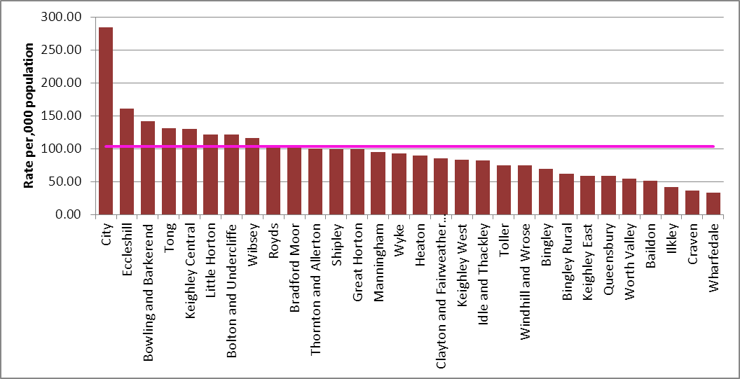

Re-offending
In 2014 around 10,680 adult and juvenile offenders were cautioned, received a non-custodial conviction at court or released from custody in Bradford. Around 2,850 of these offenders committed a proven reoffence within a year. This gives an overall proven reoffending rate of 26.7%; this rate has remained fairly stable, fluctuating between around 26% and 28% since 2004. The 2014 reoffending rate represents a small decrease of 0.4 percentage points compared to the previous 12 months and a fall of 1.6 percentage points since 2004. Around 9,780 proven reoffences were committed over the one year follow-up period, with those that reoffended committing, on average, 3.43 reoffences each. The highest reoffending rate by age group is 40.2%, for offenders aged 10 to 14. The number of offenders in this cohort has fallen by around 84% since 2004. The reoffending rate for this age group overtook offenders aged 15 to 17 in 2012, who previously had a consistently higher reoffending rate but are now second highest.

Proven reoffending statistics quarterly: January to December 2014
Local Authority | Number of offenders in cohort | Average number of reoffences per reoffender | Proportion of offenders who reoffend (%)
Leeds | 16,056 | 3.26 | 28.30%
Bradford | 10,676 | 3.43 | 26.70%
Wakefield | 5,747 | 3.27 | 26.70%
Calderdale | 3,653 | 3.22 | 26.40%
Kirklees | 7,160 | 2.90 | 24.70%
Source: Ministry of Justice, proven reoffending statistics

Antisocial Behaviour
In 2015/16, there were 16,355 incidents of antisocial behaviour (ASB) recorded by the Police, a decrease of 5.4% on the previous year. Since April 2016 there has been a further reduction in the number of ASB incidents recorded by the Police. Between 1 April 16 and 30 September 16 there were 8,727 incidents recorded, a 6.7% reduction on the same period the previous year. 35% of the total incidents during the year to 30 September 2016 were youth related. Alcohol related incidents had the largest reduction during the year to 30 September 2016 (a 21% reduction compared to the previous year – approx. 260 fewer incidents). Reported nuisance car and van incidents increased by 40% during the year to 30 September 2016 (an increase of approx. 260 incidents). This increase partially reflects the work being done to encourage people to report this type of anti-social behaviour. Since the start of February 2016 Police have been running Operation Steerside to tackle Bradford’s dangerous drivers. Just under 3,500 vehicles were stopped as part of the operation between 1 April and 30th September, a high proportion which were within the city centre.

Results from the Office of the Police and Crime Commissioner Survey show traffic and rubbish and litter lying around as the top issues for District residents. Traffic is more of an issue for residents in Bradford West NPT where during the year to 31st March 2016 74.9% of survey respondents reported a problem. Residents in the City Centre had the highest negative perceptions about rubbish and litter lying around with 73.3% of survey respondents reporting it as a problem.

Bradford has the highest percentage of residents who believe antisocial behaviour has increased in West Yorkshire at 18% for the 12 months to 31 March 2016, compared to the West Yorkshire average of 13.2%.

Drugs & Alcohol
39.2% of residents believe that there is a problem with drug use and drug dealing in their local area for the year to 31 March 2016. This is a 1.3 percentage point decrease from the same period the previous year.

4.7% of opiate users and 36% of non-opiate users successfully completed treatment and did not represent within 6 months for Quarter 2 16-17. 36.3% of individuals reporting alcohol misuse left treatment successfully.

Domestic abuse
Domestic abuse is any violent or abusive behaviour used by one person to control and dominate another with whom they have or have had a personal or family relationship. This includes physical, sexual, psychological, emotional, verbal or financial abuse.

There were 12,319 incidents of domestic abuse in 2015/16, a 13.1% increase compared to 2014/15, following a trend of increases over recent years. The increase in reported incidents is positive, suggesting more victims of domestic abuse are now seeking support. The repeat victimisation rate for domestic abuse was 37.7% in 2015/16 and 24.2% of all violent crime in the District was domestic related.

Child Sexual Exploitation
Child sexual exploitation is illegal activity by people who have power over young people and use it to sexually abuse them. This can involve a broad range of exploitative activity, from seemingly ‘consensual’ relationships and informal exchanges of sex for attention, accommodation, gifts or cigarettes, through to very serious organised crime. Estimates are based on national levels of service provision and the actual number of victims of child sexual exploitation is likely to be much higher.

Between the 1st April 2015 and the 31st March 2016 there were 531 sexual offences committed in Bradford against children who were under the age of 18 at the time the offence was committed. Of these crimes 109 (20%) were recorded as child sexual exploitation crimes.

Over the 2015/16 financial year there were 713 cases dealt with by the CSE Hub. Of these
63 were already open on the 1st April and were ongoing cases at that time. Of these referrals 217 (30%) were not identified as at risk of CSE at the time of the referral. There were 569 individual children referred to the CSE Hub and 106 of these children were referred on more than one occasion.

Road Safety
There has been a decrease in the number of casualties of all severities in road traffic collisions reported to the police in 2015. The 1,671 casualties recorded is a decrease of 4.5% on last year’s (1,750). Car occupants (-92), cyclist (-10) and motorbike riders (-4) have contributed to the overall decrease. There has been an increase in the number of pedestrian casualties of all severities (+30).

The number of people Killed or Seriously Injured (KSI) in Bradford has decreased by 7.8% (-16) to 188 in 2015 (following an increase of 7.4% the previous year to 204). Of that total, 71 were pedestrians (down 2.7% on previous year), 46 car occupants (down 33.3% on the previous year), 35 motorcycle riders (same as previous year) and 24 cyclists (up 20% on the previous year). Child KSI has increased by 17.9% from 28 to 33.

Satisfaction with the local area

Over the past three years, residents have reported relatively consistent levels of satisfaction with their local area: | 2013/14 | 2014/15 | 2015/16
% of people satisfied with their local area as a place to live | 71.2% | 70.8% | 70.2%
Source: West Yorkshire Police / Office of the Crime Commissioner’s Perception Survey

There is a strong relationship between a feeling of belonging and satisfaction with the local area: data from the Perceptions survey shows those who speak highly of their area are more than twice as likely to feel a strong sense of belonging compared to those who are dissatisfied. Community Safety has a significant influence over people thinking their area is a good place to live.

Some communities of interest are significantly less satisfied with the local area than the general population. Those with a long-term illness/disability are less satisfied than the rest of the population, as are those who act as a carer.

Community relations
As a District with both high levels of inequality and deprivation and an ethnically and culturally diverse population, Bradford faces challenges to its aspirations to be a District where people from different communities get on well together and respect and celebrate their differences.

Hate crime is an indicator of community tensions. In 2015/16 964 Hate Crimes were recorded by West Yorkshire Police, this is an increase of 77% compared to the previous year. The underreporting of hate crime, although improved, remains a challenge for the District and there is a clear need to improve reporting for Sexual Orientation, Disability, Faith and LGBT Hate Crime.

Bradford has a tradition of welcoming new arrivals from around the world and is a District where people from different backgrounds do, on the whole, get on well together. The Office of the Crime Commissioner Survey findings show improvements over the last two years in response to the question ‘% of people who agree that their local area is a place where people from different backgrounds and communities live together harmoniously’.

 | 2013/14 | 2014/15 | 2015/16
% of people who agree that their local area is a place where people from different backgrounds and communities live together harmoniously | 62.0% | 63.7% | 62.6%
Source: West Yorkshire Police / Office of the Crime Commissioner’s Perception Survey

Source Public Health England: National Drug Treatment Monitoring System (NDTMS)

