Understanding Bradford District | City of Bradford Metropolitan District Council  Intelligence Bulletin | March 2017

Early Years

At a glance:
- The Integrated Early Years Strategy is a three year strategy (2015-18) that aims to improve the life chances of children in Bradford
- In 2016 Children’s Centres provided services to 67% of all 0-4 year olds in the District.
- In January 2016, over 3,000 two year olds were accessing an early education place.
- In January 2016, over 90% of the District’s 3 and 4 year olds were accessing an early education place.
- Currently 94% of our group-based childcare settings achieve a good or outstanding Ofsted rating.

Integrated Early Years Strategy
The Integrated Early Years Strategy is a three year strategy that aims to improve the life chances of children in Bradford by addressing inequalities, narrowing the gap and improving outcomes for all children including disadvantaged children and families across the district. Evidence is clear that children’s early years experiences shape their development, educational attainment and life chances. This strategy will focus on young children’s development – ensuring they are healthy, have good parent-child relationships and are ready for their next stage of learning.
The strategy has been developed to ensure the provision of effective early childhood services through high quality universal services and timely access to specialist services as required. These services will promote prevention, early identification, intervention and targeted support. Robust partnership arrangements will be crucial to support delivery and ensure that community engagement and engagement of parents is at the heart of service approaches. This strategy recognises the wide range of partners that contribute to delivery of the strategy including local authority, health, schools, voluntary and private sector provision. They are all crucial partners in improving the life chances of children and bring different skills, resources and contributions.

Children’s Centres
There are 32 children’s centres in Bradford District with services also being delivered in an additional 9 sites. Provision is divided geographically in to 7 Clusters, the Clusters are managed by the Local Authority, Charities or by Nursery Schools. 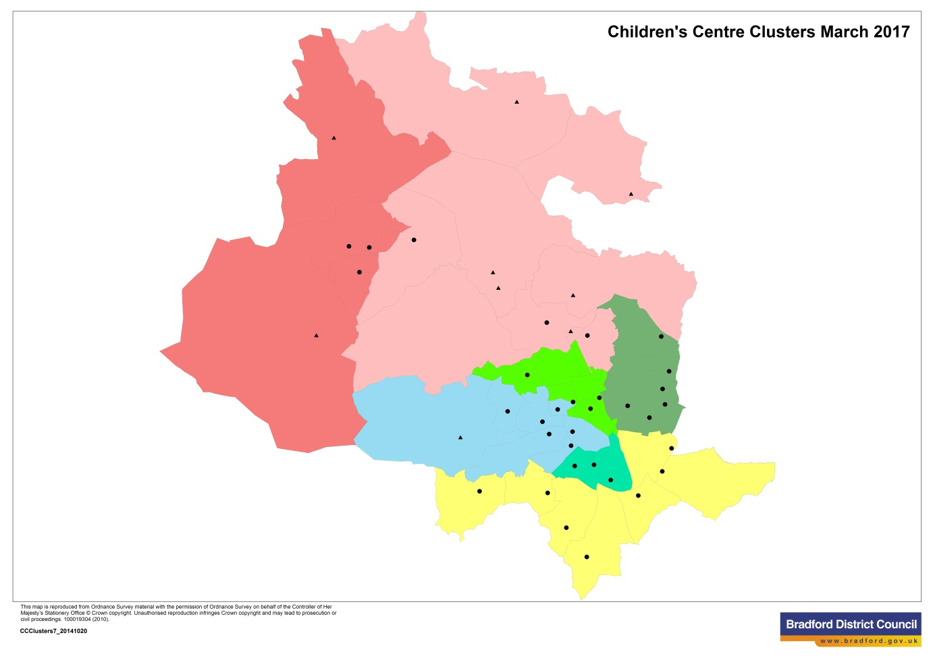
 | The Airedale & Wharfedale Cluster |  |  | Designated Children’s Centre
 | The BD5 Cluster |  |  | Outreach delivery site
 | The East Bradford Cluster
 | The Keighley Cluster
 | The Lister Park Cluster
 | The South Bradford Cluster
 | The West Bradford Cluster

Each Cluster is responsible for providing services to children (aged 0-4) and families living in their area (reach area). The universal or early years offer is available to all families:

This offer includes:
- A range of parenting courses and support
- The Family Links antenatal programme: an 8 week course for pregnant women and their partners to prepare for the birth and parenthood
- Introduction to your children's centre with support for infant feeding
- Weaning advice
- Early language development session (6 months and 18 months of age)
- Help with access to a free early education place in the term after their child’s third birthday
- Free Book Start packs
- Access to information through the Families Information Service
- Adult learning
Additional support is available for families who qualify for it, such as two-year-old early education places for eligible children.
Currently, Clusters are universally targeted on the registering, seeing (one or more times in a year) and engaging with (seeing 3 or more times in a year) children aged 0-4 living in their reach area. As at the end of Q3 2016/17, 98.5% of the District’s 0-4 population (39,992) were registered with a Children’s Centre, 66.9% had been seen one or more times in the previous 12 months and 41.4% had been seen 3 or more times.

In November 2015 the Ofsted inspection of Children’s Centres was put on hold whilst the Department of Education conducts consultation into Children’s Centres and their accountability. The latest publish statistics, August 2015, shows that 36 of our 41 centres have been inspected by Ofsted. 25 (69%) of our centres have been given an outcome of ‘good’ or ‘outstanding’. At that point in time Bradford District (69%) is performing above national (66%) and in line with regional (69%) rates for ‘good’ or ‘outstanding’.

Free 15 hour entitlement to disadvantaged 2 year olds.
In January 2016 3,040 2 year olds accessed an early education place. 78% took up their place with a PVI and 22% within the maintained sector.

80% of our 2 year olds are attending settings (PVIs and maintained schools) that Ofsted have judged to be good or outstanding.

Free 15 hour entitlement to all 3 and 4 year olds
In January 2016, 91% of 3 year olds and 97% of 4 year olds in Bradford accessed an early education place. The England comparative figures are 93% and 97% respectively. Overall 62% of 3 year olds and 89% of 4 year olds took up their place in a maintained school nursery class. 38% of 3 year olds took up their place in a private, voluntary and independent sector (PVI) provision, in a day nursery, pre-school playgroup, independent school or with a childminder.

71% of our 3 and 4 year olds are attending settings (PVIs and maintained schools) that Ofsted have judged to be good or outstanding.

Childcare
In December 2016 there were 712 registered childcare providers across the District (465 childminders, 228 day nurseries and pre-school playgroups, and 19 home childcarers), offering 11,766 registered childcare places.

The % of childminders achieving a good or outstanding Ofsted outcome has been slowing increasing over the past 5 years. Currently 91% of our childminders achieve a good or outstanding Ofsted, in line with both the regional and England figure of 91%.

The percentage of group based settings achieving a good or outstanding Ofsted outcome has been increasing over the past 5 years. Currently 94% of our group-based settings achieve a good or outstanding Ofsted compared to a regional figure of 96% and England figure of 95%.

https://www.bradford.gov.uk/children-young-people-and-families/reports-policies-projects-and-strategies/integrated-early-years-strategy/
Children's centres inspection outcomes April to August 2015
DfE Provision for Children Under Five Years of Age in England - January 2016
GOV.UK Childcare providers and inspections – December 2016

